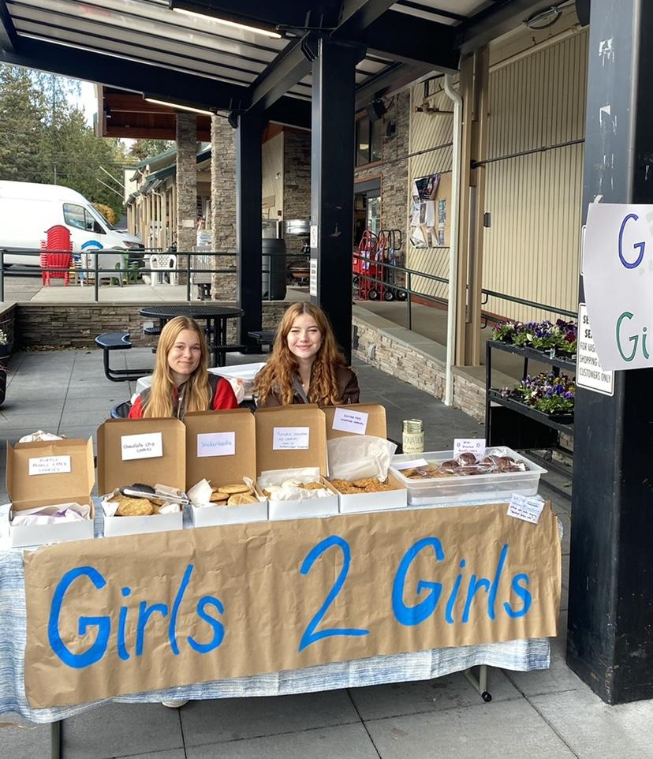
Girls to girls is back and running in-person after almost two years of being online. Because of this exciting change, we wanted to get an opportunity to share our recent successes as a club. Over the past year, we have expanded as a club more than ever, getting more girls involved in the community here and the communities in which we correspond with in Taita Taveta, Kenya. With all the new members, each person has had the chance to correspond with 1-2 girls in Kenya through Google Chat, Gmail, and Zoom meetings. These communication resources have been easily accessible this year because we supplied Chromebooks for the students in Kenya to make it easier to correspond with each other. These stay in the classrooms at school, and have been a large resource for the students. Learning how to use and having access to technology is a vitally important skill right now. Because of this new technology, our communication has been thriving as we strive to email the girls at least once a week.
As for our recent fundraisers we have had bake sales, and various other events along with our annual main fundraiser over Zoom. The first bake sale of the season was on November 5th, 2022 at the Vashon Thriftway. We sold many baked goods by donation to raise money.
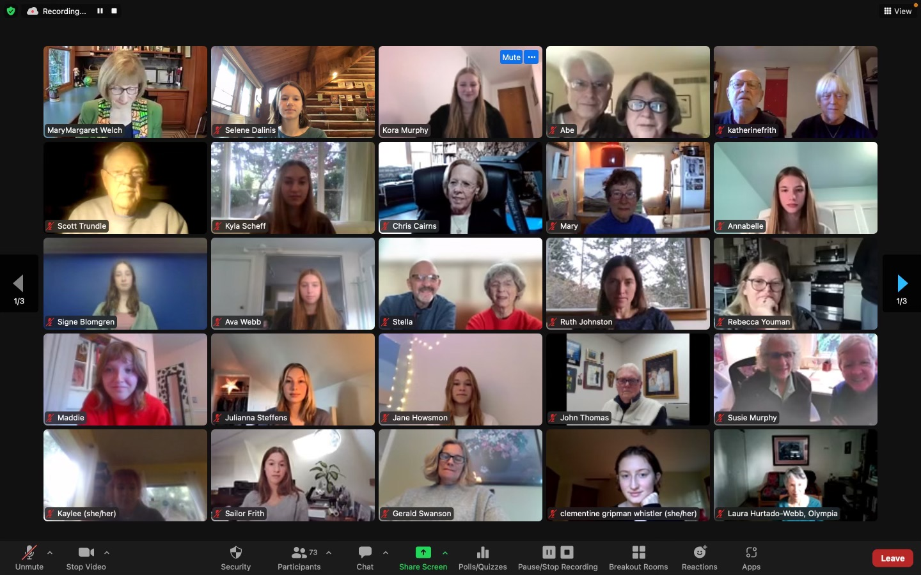
Our second fundraiser was a face painting event on Halloween night. It was a great experience to get closer to the Vashon community and spread the word through fun festivities. Last but not least, our most recent fundraisers were two Zoom calls with guests invited by each girl in the club along with friends of our advisor, MaryMargaret. We had the chance to educate people on what we do as a club and how it helps build bonds with the students in Kenya, along with presenting how they can help by donating money for the cause.
(Picture of Zoom call shown on the right)
On December 11th, we also met with another Girls to Girls club on Mercer island for scholarship selection. During this exciting event, we select the students that will receive scholarships for the upcoming year. At this year’s scholarship selection we were able to provide 96 scholarships to students. This scholarship selection was a productive and fun way for the girls in both Petri and Girls to Girls to get to experience doing things for the greater good of our community.
In the future, Girls To Girls is planning on working with Stella, SeaVuria’s scholarship coordinator in Kenyon, to form clubs in the schools in Taita-Taveta with the goal of encouraging collaborative relationships between members in Seattle and Taita-Taveta. We are always wanting to form friendships with the girls on a more personal level, so this is a good way to expand those important connections. Our main goals for this next year are cultural sensitivity, working to understand our privilege and being educated, along with having genuine, consistent, and casual communication. As for other upcoming projects in the club we are going to have several bake sales, as well as a period drive to fund period products for the girls in Kenya. We hope to expand this number in years to come with new resources and high hopes!

