Greetings PETRI Supporter,

Happy Spring! We are eager to share our seasonal update with you here.

PETRI has had an eventful and successful second half of the 2022-2023 school year. This has looked like correspondence with our pen pals, a period poverty fundraiser, the planning of our Summer STEM Camp, and a clothing drive!
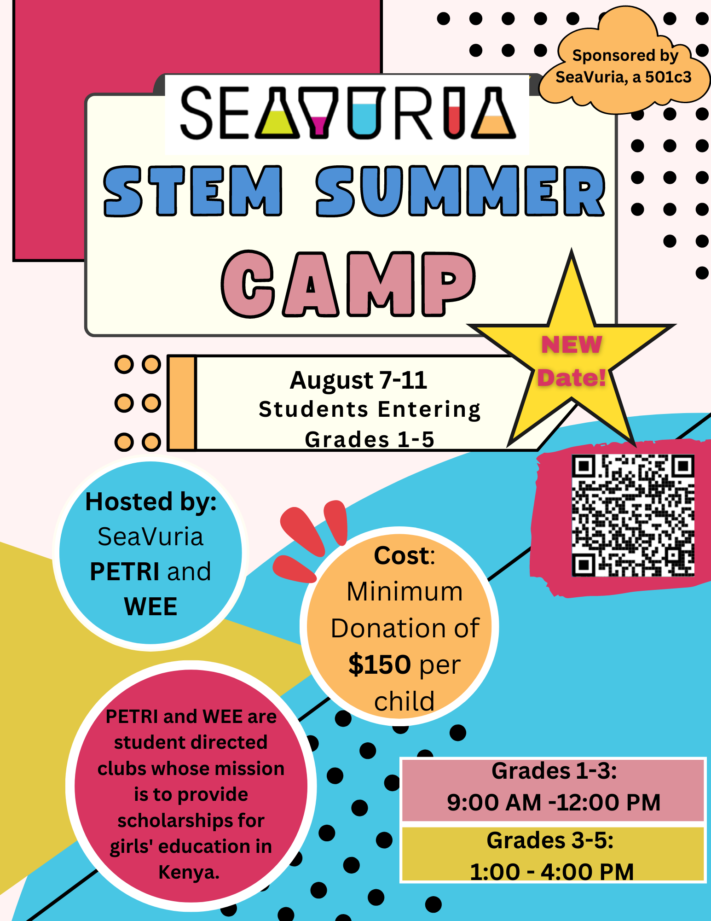
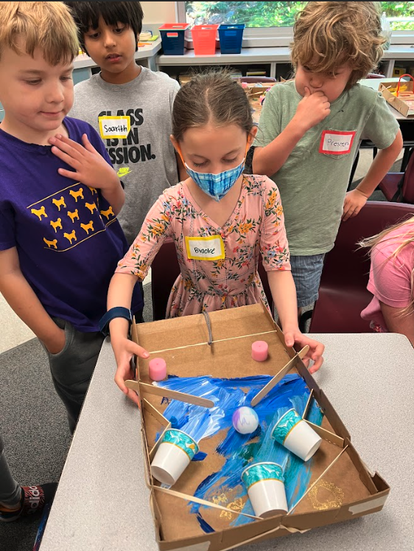
We are excited to offer Summer STEM Camp again this year. The camp will be held from August 7-11 at one of the Mercer Island Elementary Schools. Students entering Grades 1-3 will meet in from 9:00 AM - Noon to figure out how a floating train works and explain to the citizens in the town who are scheduled to receive the train. In the afternoon from 1- 4 PM we meet students entering Grades 4 and 5 and engage with the concept of electricity as they figure out why a town is experiencing frequent blackouts and make recommendations to alternative options. The camp will be taught by MaryMargaret Welch and “camp counselors” who are current or former MIHS students. The camp gives us a chance to act upon our mission to promote STEM and to earn money for our scholarship program. PLEASE HELP US GET THE WORD OUT!

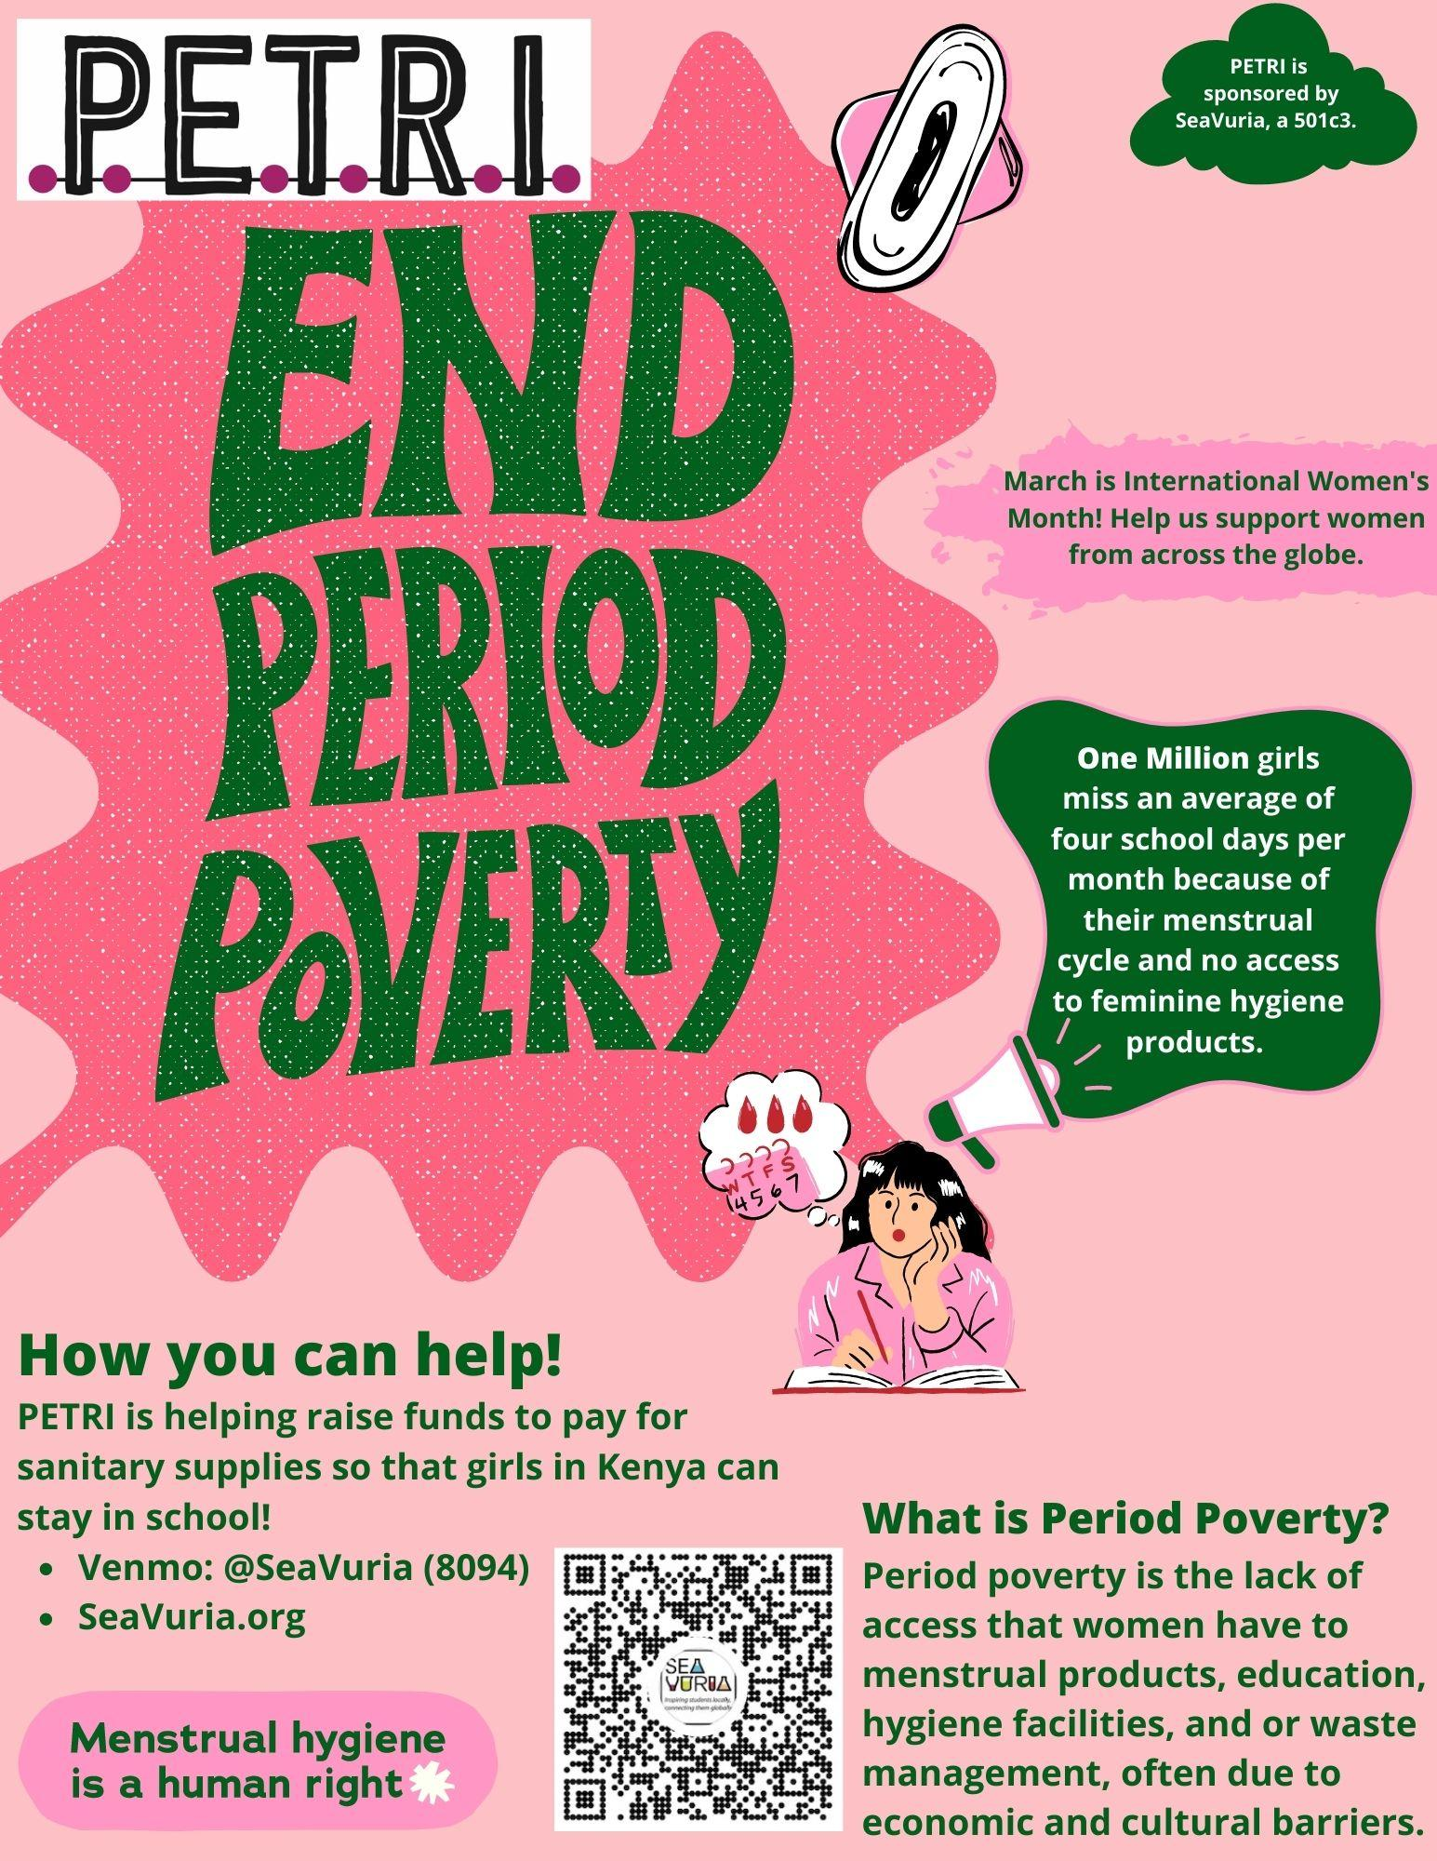
During International Women’s Month, March, we focused on building awareness of the lack of access that women around the world have to menstrual products, educational hygiene facilities, and or waste management, often due to an economic and cultural barrier! One Million girls miss an average of four school days per month because of their menstrual cycle and no access to feminine hygiene products. We want the girls we sponsor to have the same access as we do, so we focused our attention on collecting funds to purchase reusable sanitary products. Thanks to our generous supporters our campaign was VERY successful and we are now purchasing reusable pads from a local vendor in Kenya.
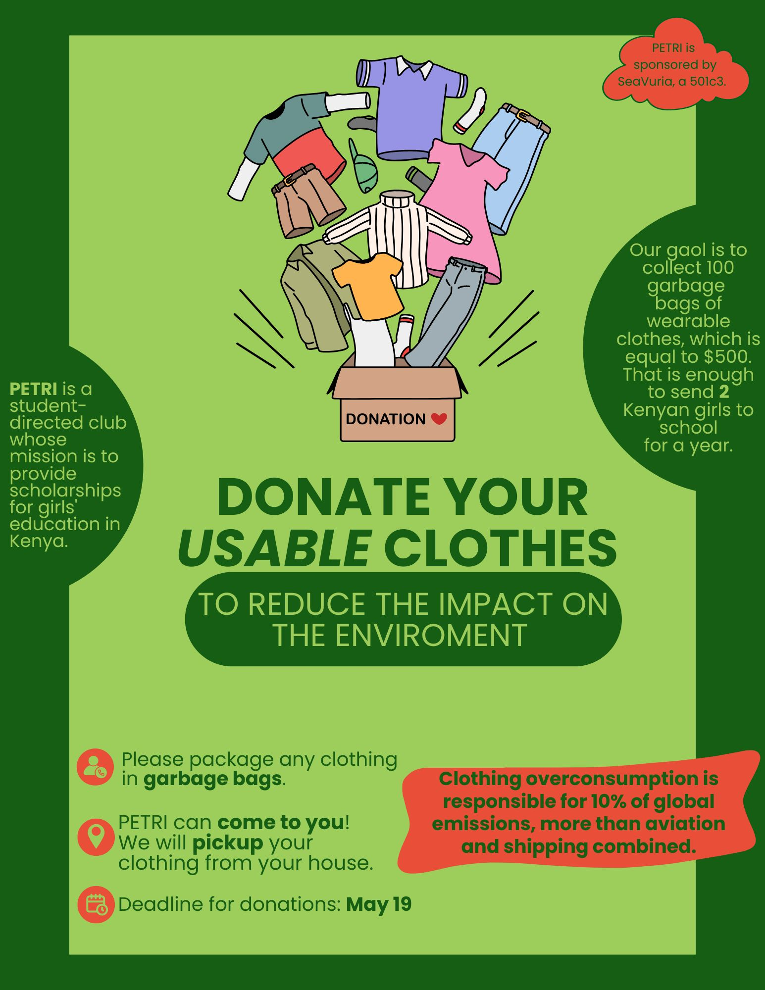
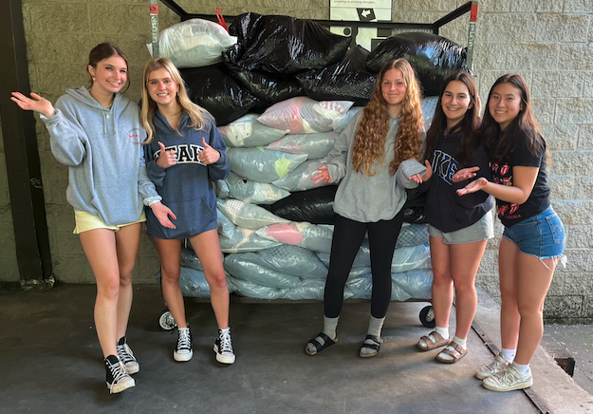
During the month of May, we did some spring cleaning and did our part to offset the impact of the fashion industries’ carbon emissions by recycling our reusable clothing. Did you know that clothing overconsumption is responsible for 10% of global emissions, more than aviation and shipping combined? PETRI’s fundraiser for this month was focused on promoting second-hand clothing, and giving a new home to clothing and accessories we no longer need! We appreciate your help with this service project which also earned us almost $500 from about 1853 pounds of clothing and home goods!

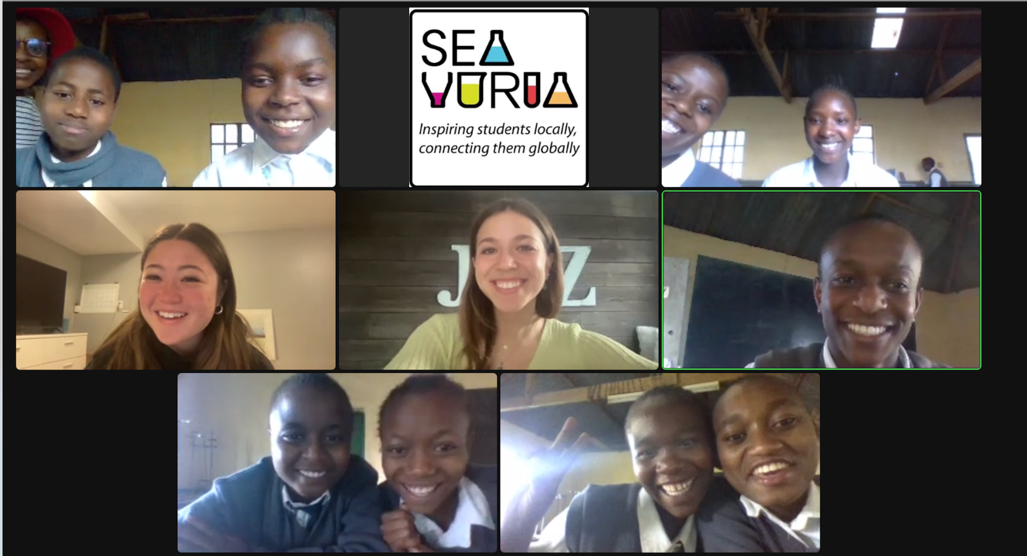
Our pen-pal communication is still going strong! For the last couple of months, PETRI has had the opportunity to participate in ZOOM’s with our pen pals from Kenya, where we are able to have one-on-one conversations and get to know each other better. These ZOOM’s are a great way to be able to foster relationships with the students we sponsor, and make amazing friends from across the world! The ability to talk over video chat has greatly benefitted our communication, as it allows us to have much more in-depth conversations than through writing. Additionally, PETRI has been continuing to utilize email and Google Chat to communicate with our pen pals weekly. Each and every one of these forms of communication has been extremely successful! As was stated by one of our friends in Kenya, “the calls are so nice to share with one another about our school, our families, our passions and just to get to know a friend from the US!”

If you would like to support us, the links to our Venmo, PayPal, and Zelle are down below. If you know of an MIHS student who would like to join our club, have them get in touch with us. We always welcome new members!
- Link to Venmo
- Link to Zelle- (enroll and then add seavuria@gmail.com as a business SEAVURIA)
- Link to PayPal
- Link to our website
- Contact us at seavuria@gmail.com
With gratitude,
SeaVuria PETRI

Alexandra Hyman, Communications VP

