Dear PETRI Supporter,

Greeting:

Recent summer & school-year updates:

PHOTO(S):

Upcoming (fundraisers, meetings, bonding, etc.):

BIG ANNUAL FUNDRAISER:

If you would like to continue receiving seasonal (quarterly) emails from Seavuria PETRI with updates on both the Washingtonian and Kenyan sides of the organization, YAY, we are so excited to have you! If not, please respond to this email with a simple “no thank you” or anything else that clearly communicates a similar message, we will miss you! Feel free to email our communications VP, Alexandra Hyman at alexhyman10@outlook.com, our co-president Katie Friedman, at kathryndfriedman@gmail.com or our advisor, Mary Margaret Welch, at seavuria@gmail.com if you have any questions or are interested to learn more.

Also, if you have friends or family members that you expect would share our enthusiasm and enjoy receiving our newsletter, feel free to forward them this email. If they decide they are interested, they can email us directly at any of the emails above.

We are so grateful for your support of our club PETRI and for helping us make a difference in the lives of Kenyan youth. Happy Autumn!

With gratitude,
SeaVuria PETRI

Seavuria PETRI website: https://www.seavuria.org/petri
Seavuria PETRI Instagram: seavuria.petri
Seavuria PETRI Facebook: Seavuria PETRI
Nextdoor page: Coming soon! Stay tuned :)

Written by Social Media VP Alexandra Hyman, Co-President Katie Friedman, advisor/sponsor Mary Margaret Welch

READY TO PUBLISH START HERE:
Happy Fall! We are back and eager to share an update with you.
PETRI had an amazing summer, filled with frequent correspondence with our scholarship recipients and a huge focus on science. Additionally, at the end of this past school year PETRI was selected to be the philanthropy focus of the ceramics class. The ceramics class auctioned off their pottery creations through an event called Empty Bowls, and donated all of the proceedings to us! PETRI is so grateful to have been chosen this past year. 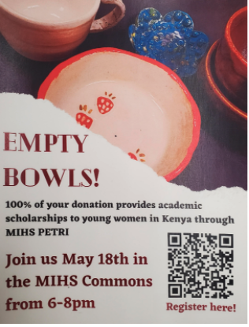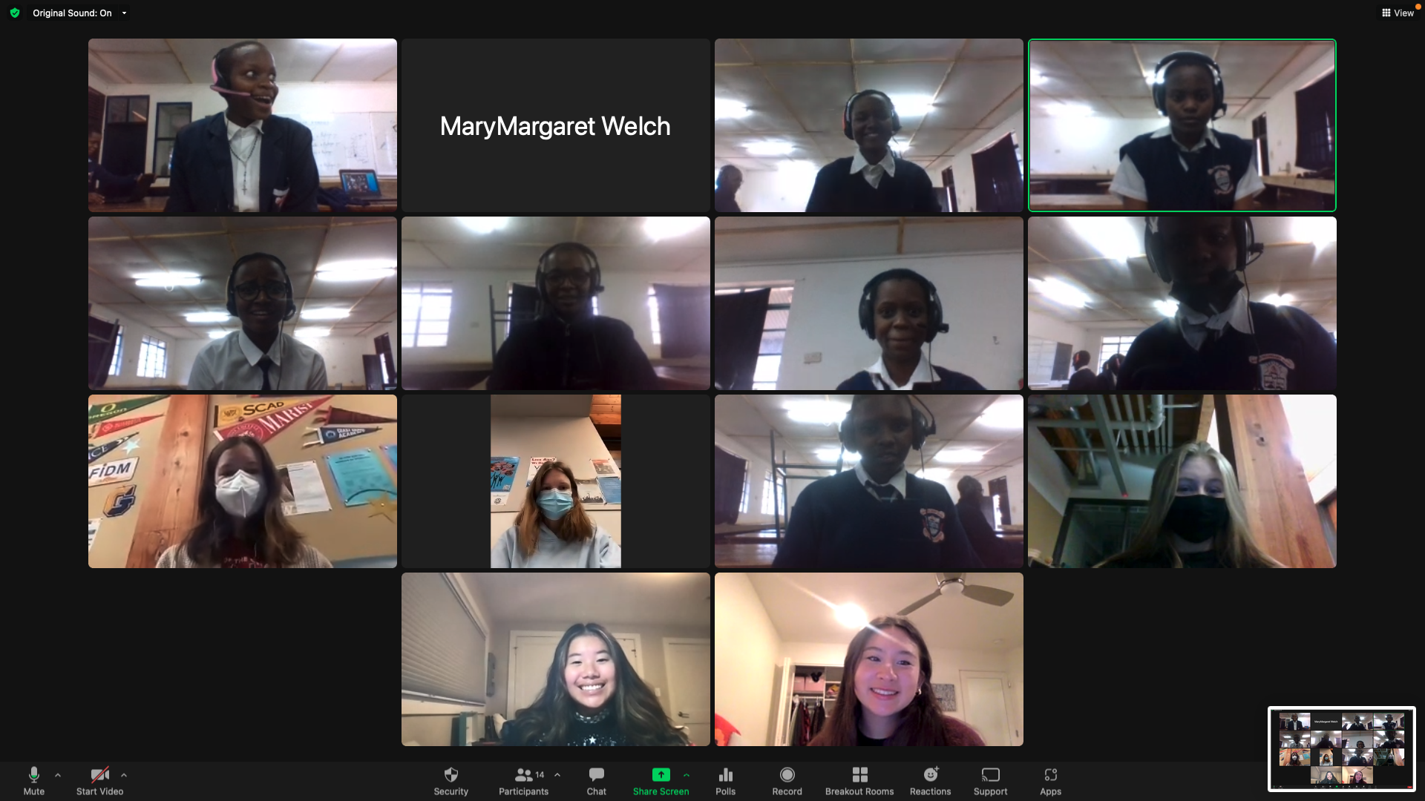

https://drive.google.com/file/d/17u7hknTLMrO25RxgHFrq0bqW3GNRgAic/view?usp=sharing

Throughout the summer, there were conversations happening between many of our very own PETRI members and the scholarship recipients. Improved conversation is due in large to the new chrome books that the recipients in Kenya received. These new chrome books have allowed us to have much more personal communication with our Kenyan friends.
In keeping with our mission, PETRI hosted an amazing STEM camp this summer! The camp was five days long, with 20 elementary age students participating. The camp was extremely successful, and was supervised by PETRI and WEE members. WEE is our college age branch of PETRI! MM Welch lead the curriculum for the camp. Parents and kids were very happy with the experience and asked us to do more camps in the future.
We have launched our new school year with a first meeting, and we have approximately 30 members as of now! This year our annual scholarship fundraising event via ZOOM will take place Nov. 13 and Nov. 20. We are so excited to see what this new year brings and can’t wait to let you know all about it!
“If you would like to continue receiving seasonal (quarterly) emails from Seavuria PETRI with updates on both the Washingtonian and Kenyan sides of the organization, YAY, we are so excited to have you! If not, please respond to this email with a simple “no thank you” or anything else that clearly communicates a similar message, we will miss you! Feel free to email our communications VP, Alexandra Hyman at alexhyman10@outlook.com, our co-president Katie Friedman, at kathryndfriedman@gmail.com or our advisor, Mary Margaret Welch, at seavuria@gmail.com if you have any questions or are interested to learn more.” Or simply visit our webpage: https://www.seavuria.org

